**HOME AUTOMATION PROJECT USING ESP8266**

**Introduction**

This project presents a design and prototype implementation of new home automation system that uses WiFi technology as a network infrastructure connecting its parts. It aims at designing an advanced home automation system using normal web server and WiFi technology. The devices can be switched on and off, and sensors can be read using a PC through WiFi.

Automation has a greater importance than any other technology due to its user friendly nature. These can be used as a replacement to existing switches at home which produce sparks and can also result in fire accidents in some situations.

**Why did we decide to make this project?**

The main objectives of this project include the making of a low cost and scalable home automation system. This obviously results in reduction of human effort. This technology is easily accessible to handicapped or physically challenged people, and makes it easier for them to use and operate electrical appliances. Moreover, this technology is time efficient as well. When used at a broader level, it helps in saving the power.

The project also includes the automatic door system, in which the door opens automatically after sensing the person.

**Materials and Methods**

Components used:

* Hardware:

|  |  |  |  |
| --- | --- | --- | --- |
| S. No. | Component | Picture | Description |
|  | Arduino Uno Board |  | It is a microcontroller board based on the ATmega328.It has 20 digital input/output pins, a 16MHz resonator, a USB connection, a power jack, an in-circuit system programming header, and a reset button. |
| 2. | Node MCU |  | It is an open source IoT platform. It includes firmware which runs on ESP8266 WiFi Soc from Espressif. |
| 3. | Ultrasonic Sensor |  | They measure distance by using ultrasonic waves. The sensor head emits an ultrasonic wave and receives the wave reflected back from the target. They measure the distance to the target by measuring the time between emission and reception. |
| 4. | Relay Module |  | The relay module is an electrically operated switch that allows you to turn on or off the circuit using voltage or current much higher than a microcontroller could handle. |
| 5. | Servo Motor |  | It is a rotary or linear actuator that allows for precise control of angular or linear position, velocity and acceleration. |
| 6. | Battery 9V |  |  |

Mechanical Materials:

* Wood
* Fevicol
* Acrylic Sheet
* Screws and Nuts
* L bents
* Home electrical appliances, eg, bulb, fan etc
* Software:

Arduino IDE:

Arduino consists of both a physical programmable circuit board and IDE (Integrated Development Environment) that runs on your computer, used to write and upload computer code to the physical board.

Fritzing:

Fritzing is an open source hardware initiative that makes electronics accessible as a creative material for anyone. It is a software tool and community website for processing and Arduino, fostering a creative ecosystem which allows users to document their prototypes, share them with others, and manufacture professional PCB’s.

Method

Step 1:

Circuit Designing

Node MCU is connected to the bulb. ESP8266 is the module connected which helps in connection to WiFi. The Node MCU consists of pins through which various electrical components are attached.The power supply is given via a USB port connection or a powerbank.

Step 2:

Procedure

1. Create an account in google firebase in order to get server to transfer our data from Android Phone to Node MCU via internet.
2. Upload the programming code produced from Arduino IDE to Node MCU.
3. The connections required are done.
4. Create an application from MIT App Inventor 2 in order to send commands from android device to Node MCU
5. Finally connect the Node MCU to WiFi Module and phone to internet connection and use the app to operate the lighting.

**Schematics**

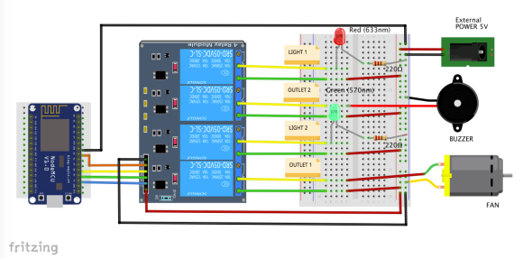

**Cad Model**

**Steps:**

1. Taking the base of dimension (8.5*6+1)*(8.5*3+7.3)cm.
2. The making of box with height of 2*8.5+7 cm.
3. The making of partition at 8.5+6 cm distance with length 6*8.5+1 cm
4. Then in one partition there is another partition of dimension (8.5+7.5)cm*(8.5+6)cm*(2*8.5+7)cm from one end.
5. In second partition there is also another partition of dimension (8.5*5+2+8)cm*(8.5+8)cm from one end
6. Insert all electronic parts in the box.

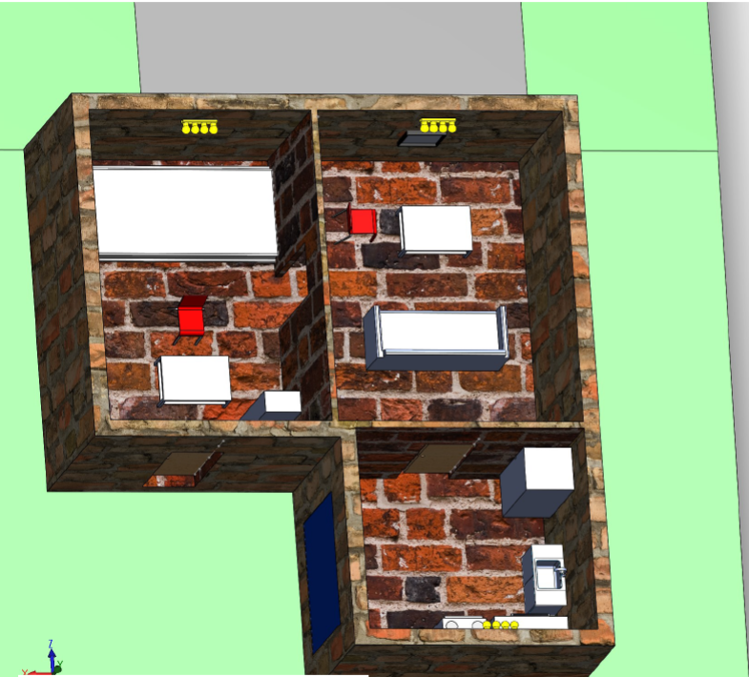

**Future Scope**

1. It is cost effective as compared to other market products.

2. It is easy to use.

3. It is really useful for physically handicapped people.

4. This has multiple uses.

5. In the fast moving generation, this technology is very time efficient.